**Data Pump Import  
-------------------------**

1)To export a schema using EM, open a web browser point it to

https://<hostname>:1158/em

2)Ensure that DBConsole service is switched on for the Enterprise manager to be served

3)Log in SYSTEM/<password>

4)Click on Data Movement link. this displays the login entry screen

5)Click Import from files link

6)Select the directory object and enter the dump file name.Set the Import type to tables and enter the host username and password.Click Continue.

7)The import files are read

8)Enter <schemaName> ganesh in the schema field and click Go

9)Select the desired tables using check boxes and click select

10)Click next

11)Use this to screen to re-map Schemas if required. this is useful if tables from one schema need to be imported to another schema

12)Click next. Select appropriate directory object and enter the log file name in the log file.

13)Click on Next, Enter job name and select Immediately options under the start sections.Click Next.

14)Click Submit job, after some time

15)Click IMPORT_GANESHSCHEMA link to view the job_summary. this displays a screen

16)Click step:Import link to view the log.

17)the import has completely successfully.-----with Screenshot

-Log into

https://<hostname>:1158/em

Step 1:

login with the system and password

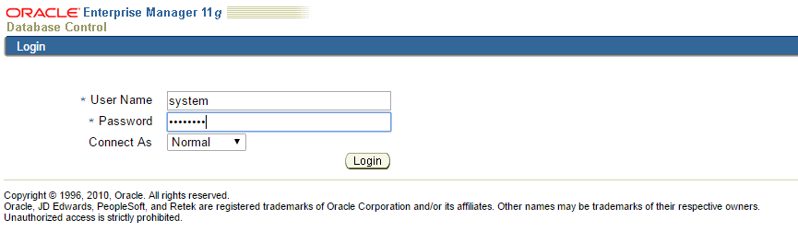

…..Continue